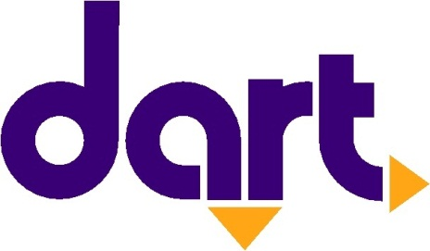

Contact
Erin Hockman
Des Moines Area Regional Transit Authority
ehockman@ridedart.com
515-499-3069

FOR IMMEDIATE RELEASE:

Tuesday, May 12, 2020

DART announces executive leadership promotions
Wanke named COO and Deputy CEO; Montoya and Hockman also promoted

The Des Moines Area Regional Transit Authority (DART) today announced a series of promotions to support the organization’s ability to be nimble, innovative and strategic in pursuit of DART’s vision to facilitate affordable, seamless mobility options that support economic prosperity for all.

Amanda Wanke was named Chief Operations Officer (COO) overseeing the operations team, as well as serving as Deputy Chief Executive Officer. Wanke, who previously served five years as DART’s Chief External Affairs Officer, will now lead approximately 200 team members within the transportation, maintenance and customer service departments. DART also realigned key functions and promoted Luis Montoya to Chief Planning Officer and Erin Hockman to Chief External Affairs Officer.

“One of the most important responsibilities of being a CEO is providing certainty and strength through talent development and continuity of leadership. This includes having the staff and structure to be nimble, strategic and well-coordinated across the organization,” said Elizabeth Presutti, DART CEO. “Today’s announcements are part of a plan to ensure that DART, as an essential service provider, is in the strongest position possible for taking care of our employees, riders and the community at large.”

Organizational structure changes included streamlining and linking key functions — with Montoya overseeing transit planning and scheduling, customer facility planning, strategic planning and business analytics, and Hockman leading marketing and communications, business and community partnerships, government relations and RideShare, a popular vanpool service.

Brief Backgrounds
Amanda Wanke
Prior to joining DART, Wanke led communications and marketing for the Agricultural Utilization Research Institute; directed communications, crisis preparedness and government relations for Bethel University; and served as press secretary and legislative assistant to a member of Congress. She has a master’s degree in organizational leadership and a Bachelor of Arts degree in political science and communications. She also completed Drake’s Executive leadership program, has the highest accreditation in public relations (APR) and is a graduate of the Greater Des Moines Leadership Institute.

Luis Montoya
Montoya joined DART in 2018 and since then has led the planning and implementation of two major service changes as well as DART’s first mobility on demand pilot. Before joining DART, Montoya was the Director of Livable Streets for the San Francisco Municipal Transportation Agency. He holds a master’s degree in city planning from Massachusetts Institute of Technology (MIT).

Erin Hockman
Hockman has been with DART for four years and came from Kemin Industries, a global nutritional ingredient manufacturing company, where she worked for more than eight years in areas of marketing, corporate communications and employee relations. Erin has a business and communications degree from Truman State University. She is also in this year’s Greater Des Moines Leadership Institute CLP class and was recently selected into the Business Record’s 2020 Forty Under 40 Class.

Click here to download images.

The Des Moines Area Regional Transit Authority (DART) is Iowa’s largest, and only, regional transit agency, providing service in and around Polk County. DART operates a family of transportation services, providing nearly 4.5 million annual rides that connect thousands of people every day to jobs, school, healthcare and other essential destinations. Twelve member governments make up DART’s service area, where the agency carries out its mission to enrich lives, connect communities and expand opportunities for central Iowans. For more information about DART services, schedules, route changes, or directions to the nearest DART stop, visit the website at ridedart.com, download the free MyDART app or call 515-283-8100.

# # #

